

**School of Computer Science Engineering and Application**

**BCA TY SEM VI**

**Subject Name: Container Orchestration**

**Lab Assignment No.5**

**Aim: Implementing AWS ECS (Elastic Container Service) and Fargate deploying and managing containerized applications.**

**Submitted By**

**Name: Prateek Gupta**

**PRN: 20210801002**

**Date: 4 March 2024**

**Aim: Implementing AWS ECS (Elastic Container Service) and Fargate deploying and managing containerized applications.**

**Technology Used: Docker, Container, AWS**

**EC2**

**Step 1: Browse for ECS (Elastic container service) and create a cluster for EC2 instance type**

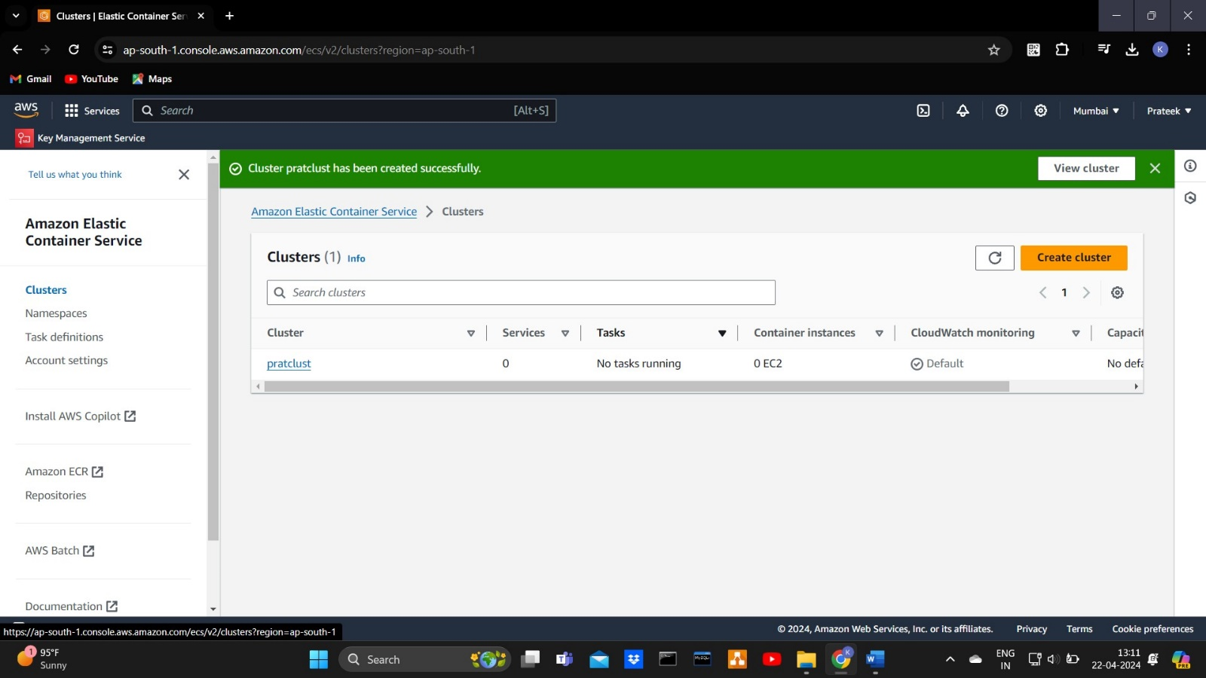

**Step 2: create task definitions**

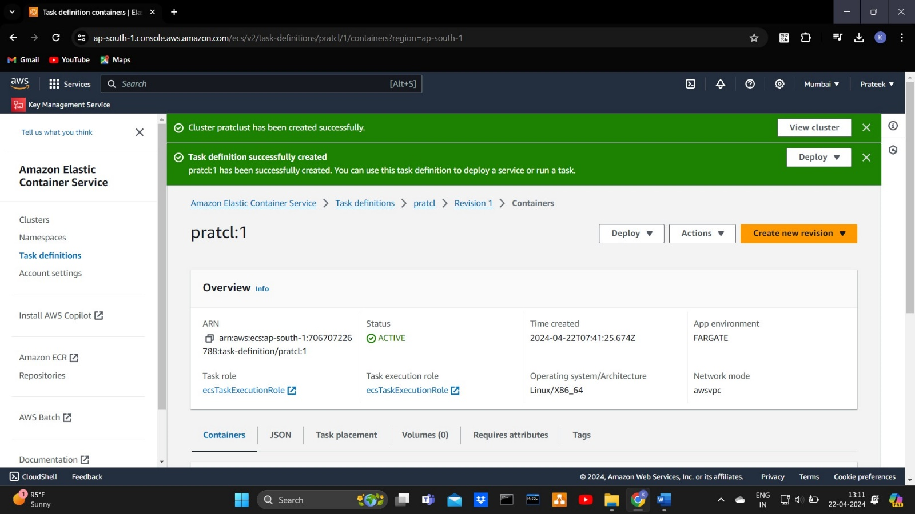

**Step 3: Deploy the created task and check for the running instances in EC2**

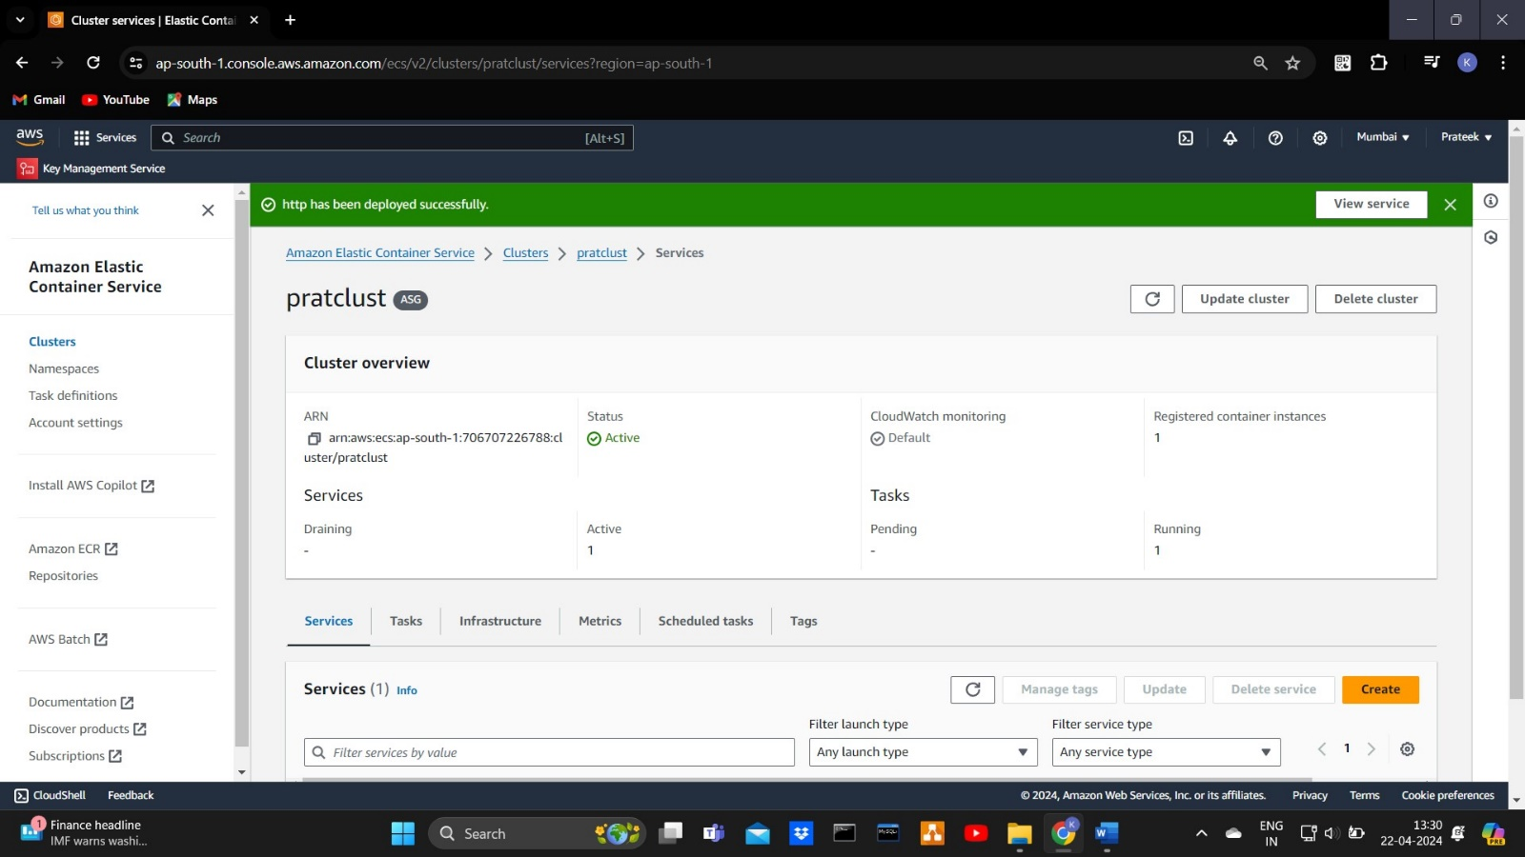

**Step 4: Connect the instance using the third-party connection using the SSH client in your Windows PowerShell**

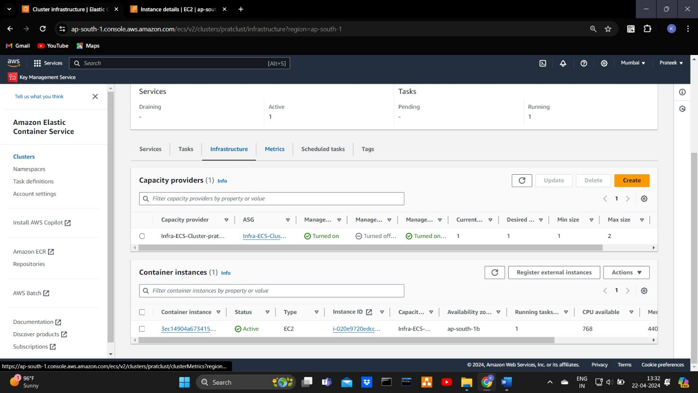

**Note: - To connect the SSH client the key.pem pair should be installed in your system otherwise it will deny the permission to connect.**

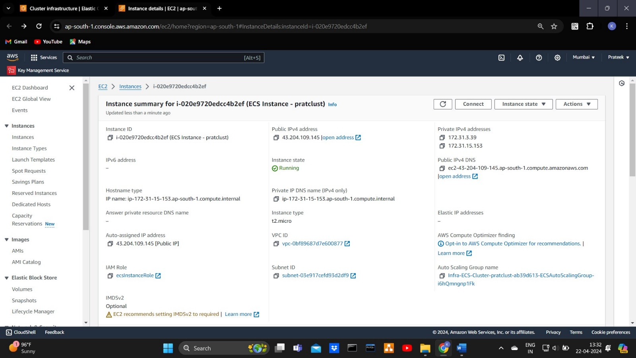

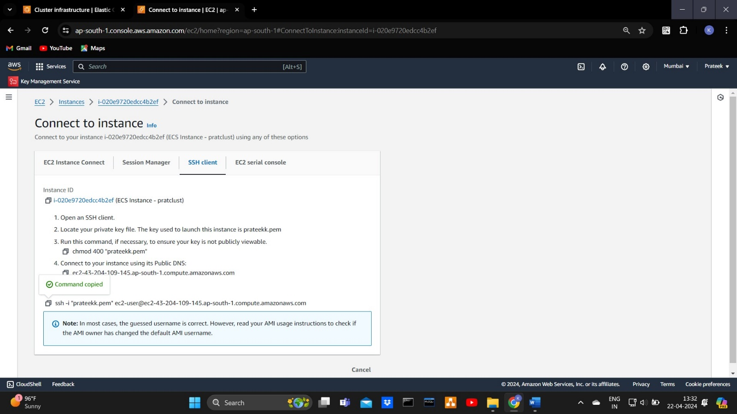

**Cmd: $docker ps**

**To show the image we installed (httpd)**

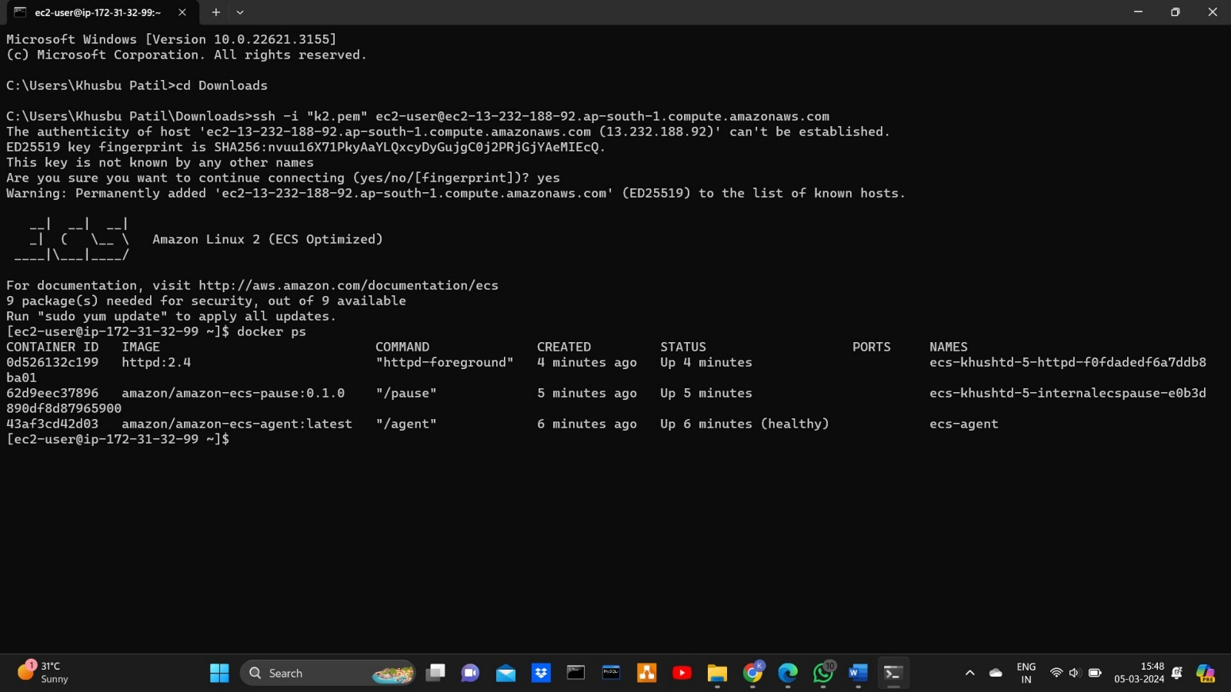

**FARGATE(serverless)**

**Step 1: Create cluster for Fargate(serverless)**



**Step 2: Create task definitions**

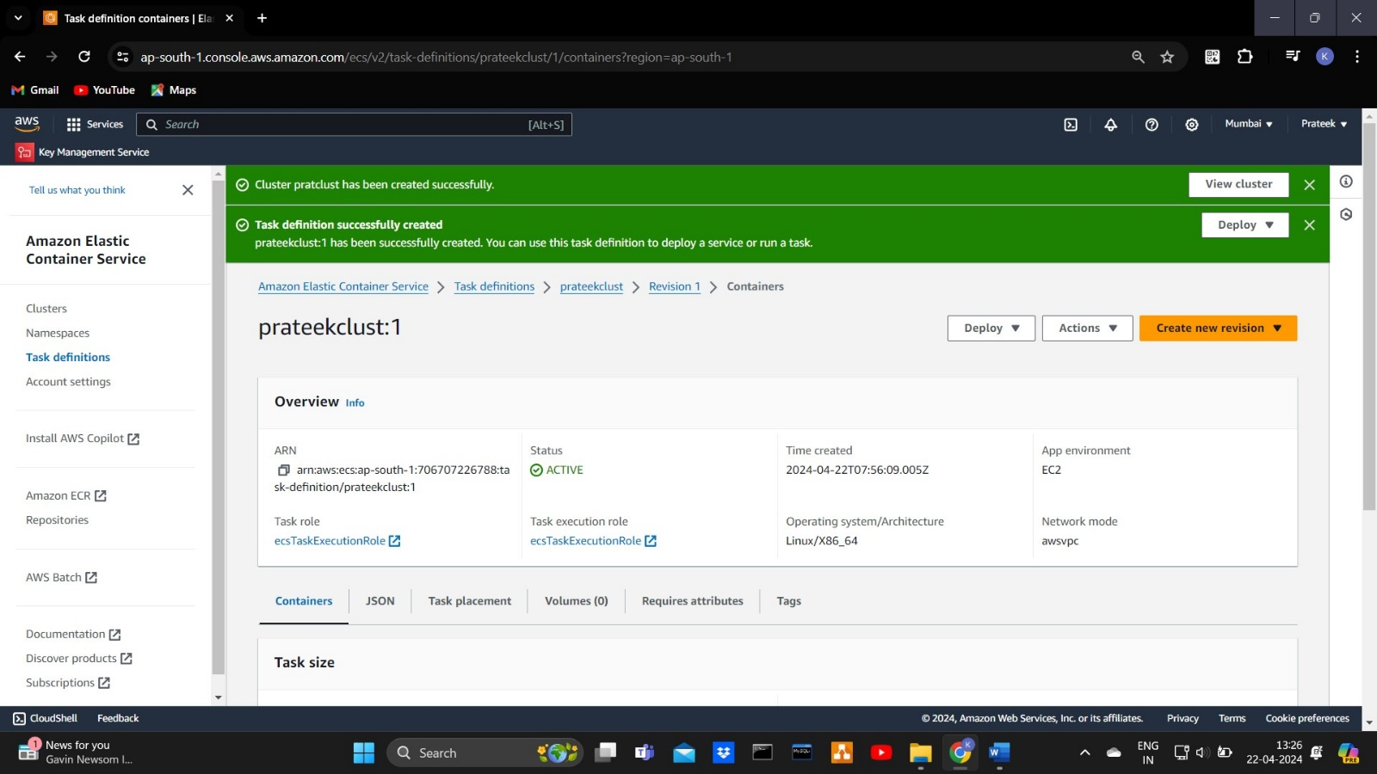

**Step 3: Deploy the task and create service**

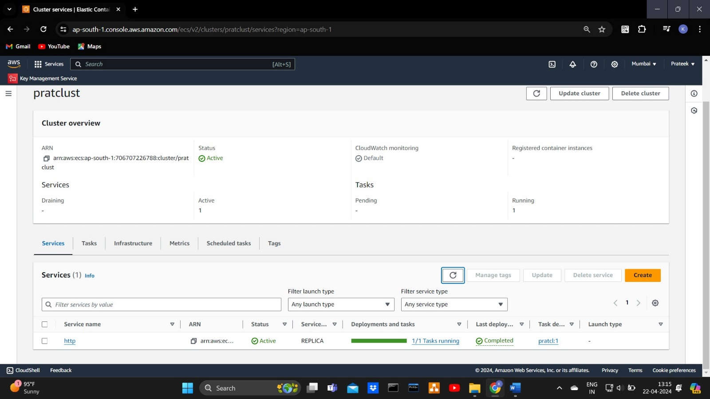

**Step 4: Go to cluster>task>click on the task>open the public ip address to know whether the service is working or not**

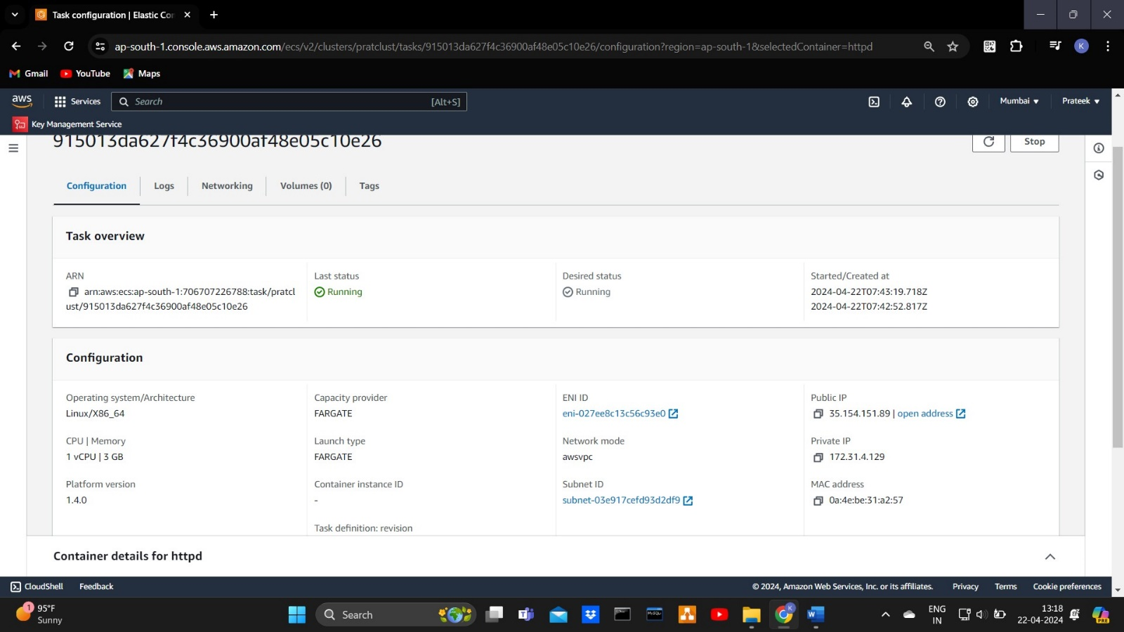

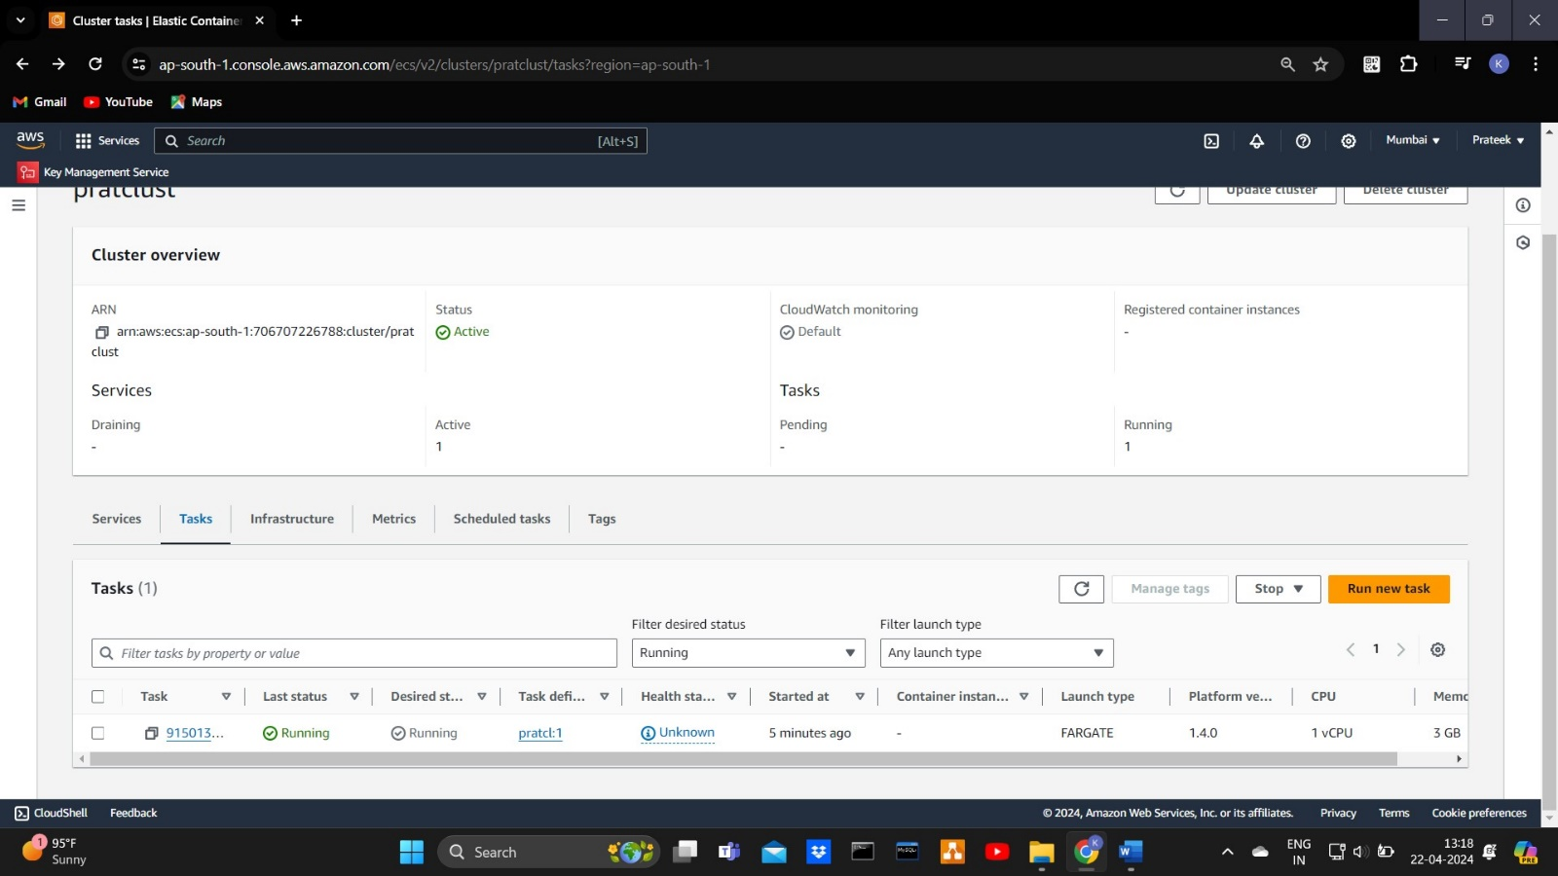

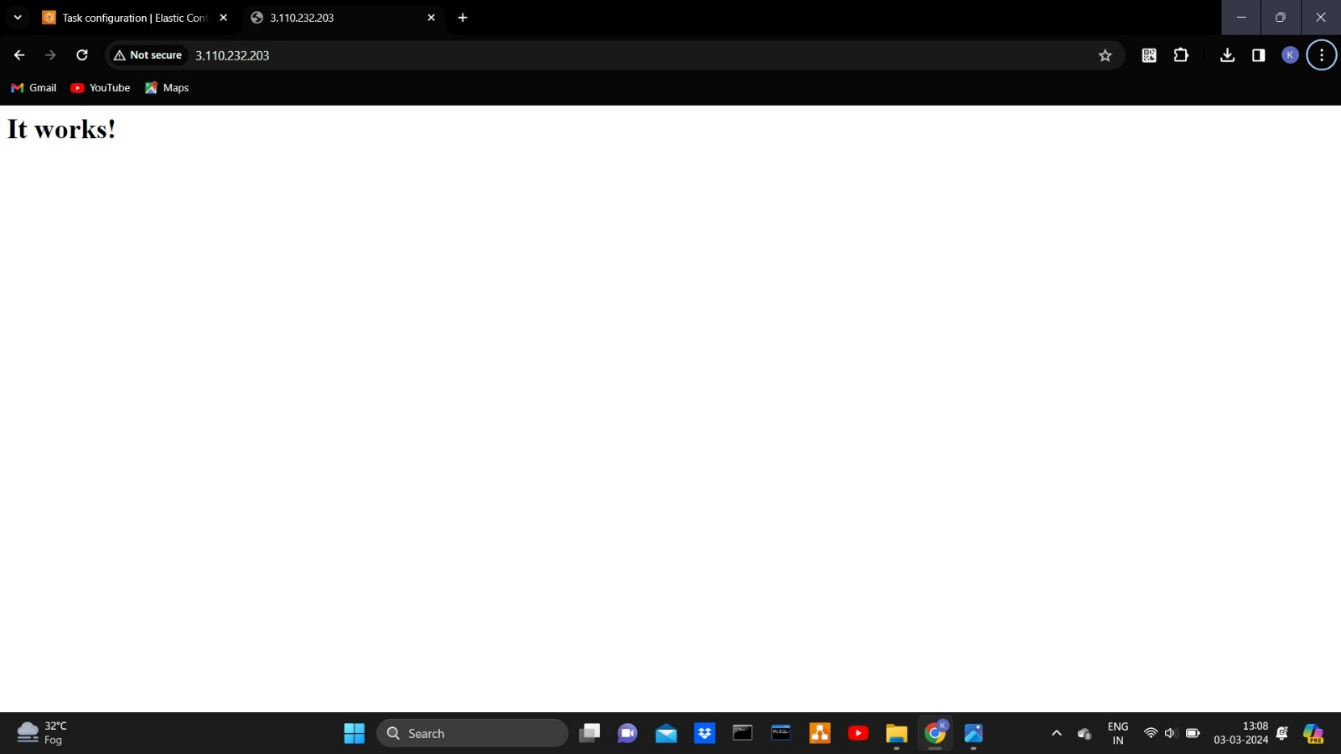

**End of the practical**

**Sign**

**Subject In-charge: Dr. Swapnil Waghmare**